

**Guide to Updating Your Profile in**

**Maine JobLink (MJL) for**

**Apprentices with existing JobLink accounts**



As a registered apprentice (RA) with the Maine Apprenticeship Program, all apprentices are required to be registered as an apprentice in the Maine Job Link (MJL) for federal funding purposes and case management.

MJL is a free and easy cloud-based job board that features improved job search and job matching functions, notifications of job match by email, a professional resume builder, support for more than 60 languages using Google Translate and a mobile-friendly design for smartphones and tablets.

The MJL website strives to comply with the best practices and standards as defined by Section 508 of the U.S. Rehabilitation Act and Level AA of the World Wide Web Consortium (WC3) Web Content Accessibility Guidelines 2.0. These guidelines outline how to make web content more accessible for people with disabilities.

 *The Maine Department of Labor provides equal opportunity in employment and programs. Auxiliary aids and services are available to individuals with disabilities upon request. This program is provided in partnership with the American Job Center network.*

**Before you begin, you must know your Registered Apprentice Number (if you do not know your apprentice number contact your employer or the Maine Apprenticeship Program at 623-7969). You can also find your apprenticeship number on the printed Apprenticeship Registration Form that was sent to you in your welcome packet.**

**To access the Maine JobLink website:** <https://joblink.maine.gov>

**Step 1: Sign in to your account**



**Step 2: Click on My Profile on the left-hand side of the web page**

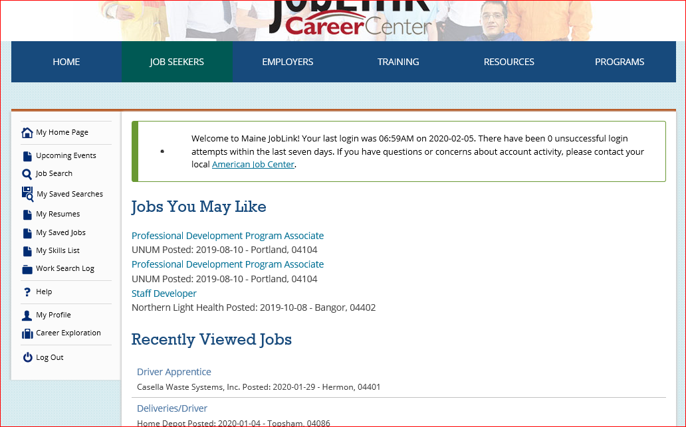

**Step 3: Scroll down and click on Personal Information**

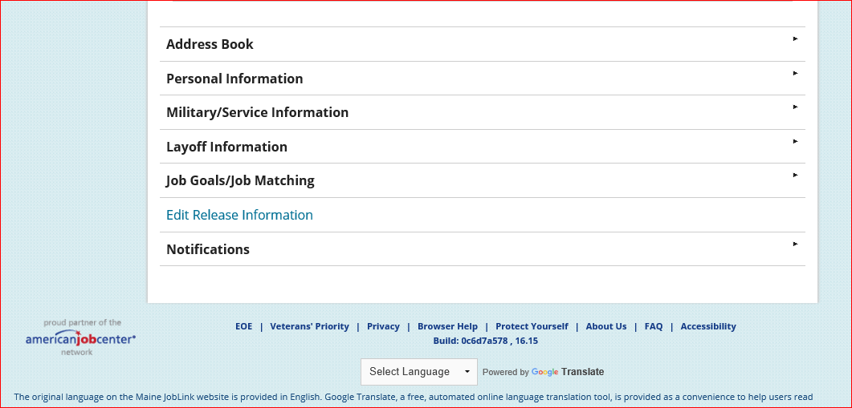

**Step 4: Click on Edit Personal Information**

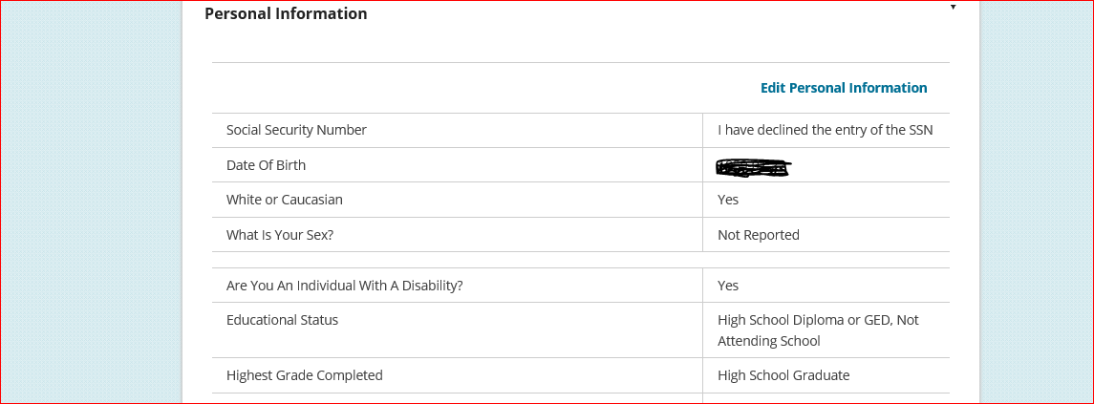

**Step 5: Click on Registration Information**

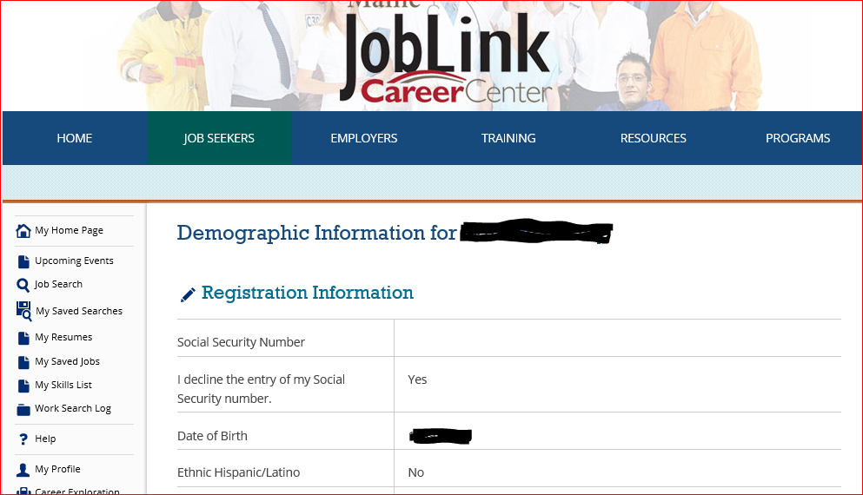

**Step 6: Scroll down until you see the question “Are you a Registered Apprentice?”**

**-Select Yes.**

**-Enter your Registered Apprentice Number in the next box (if you do not know your apprentice number contact your employer or the Maine Apprenticeship Program at 623-7969).**

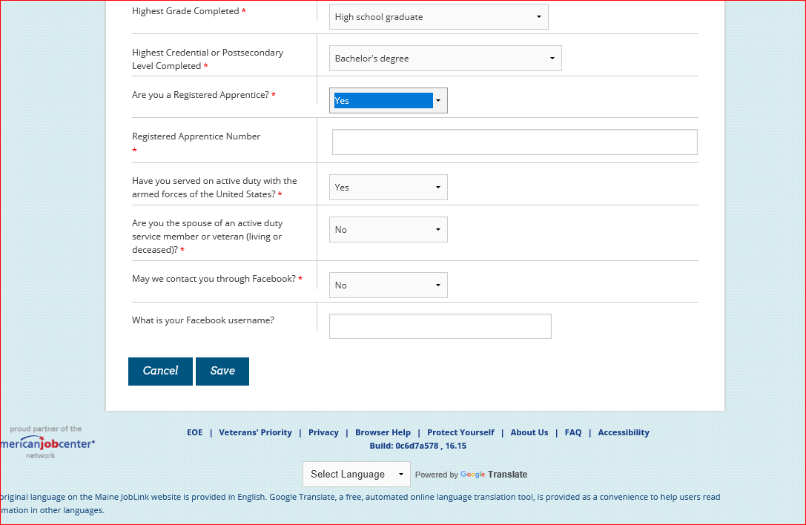

**-You can also find your apprenticeship number on the printed Apprenticeship Registration Form that was sent to you in your welcome packet.**

**-Finally, you must click the “Save” button at the bottom of the page.**

**-You are done!**